**MID TERM**



**Name**

Sherly Lutfi Azkiah Sulistyawati

**NIM**

2341720241

**Class**

1I

**Department**

Information Technology

**Study Program**

D4 Informatics Engineering

Question 1

A software development company is looking to hire new employees with exceptional programming talent. They have unique criteria for the selection process:

1. Employees must be able to solve complex mathematical problems in a short time, specifically less than 180 minutes.
2. Employees must have in-depth knowledge of programming languages, mastering at least 3 types of programming languages.
3. Employees must have graduated from a D4 or S1 program in Teknik Informatika/Ilmu Komputer/Rekayasa Perangkat Lunak/Sistem Informasi.
4. Employees should have at least 1 year of work experience.
5. Employees must have passed the interview.

Employees who meet all these criteria are considered to have passed the selection, otherwise, they are considered to have failed the selection.

Create a program in Java (60%) and complete it with an explanation in the form of a flowchart or narrative (40%)!

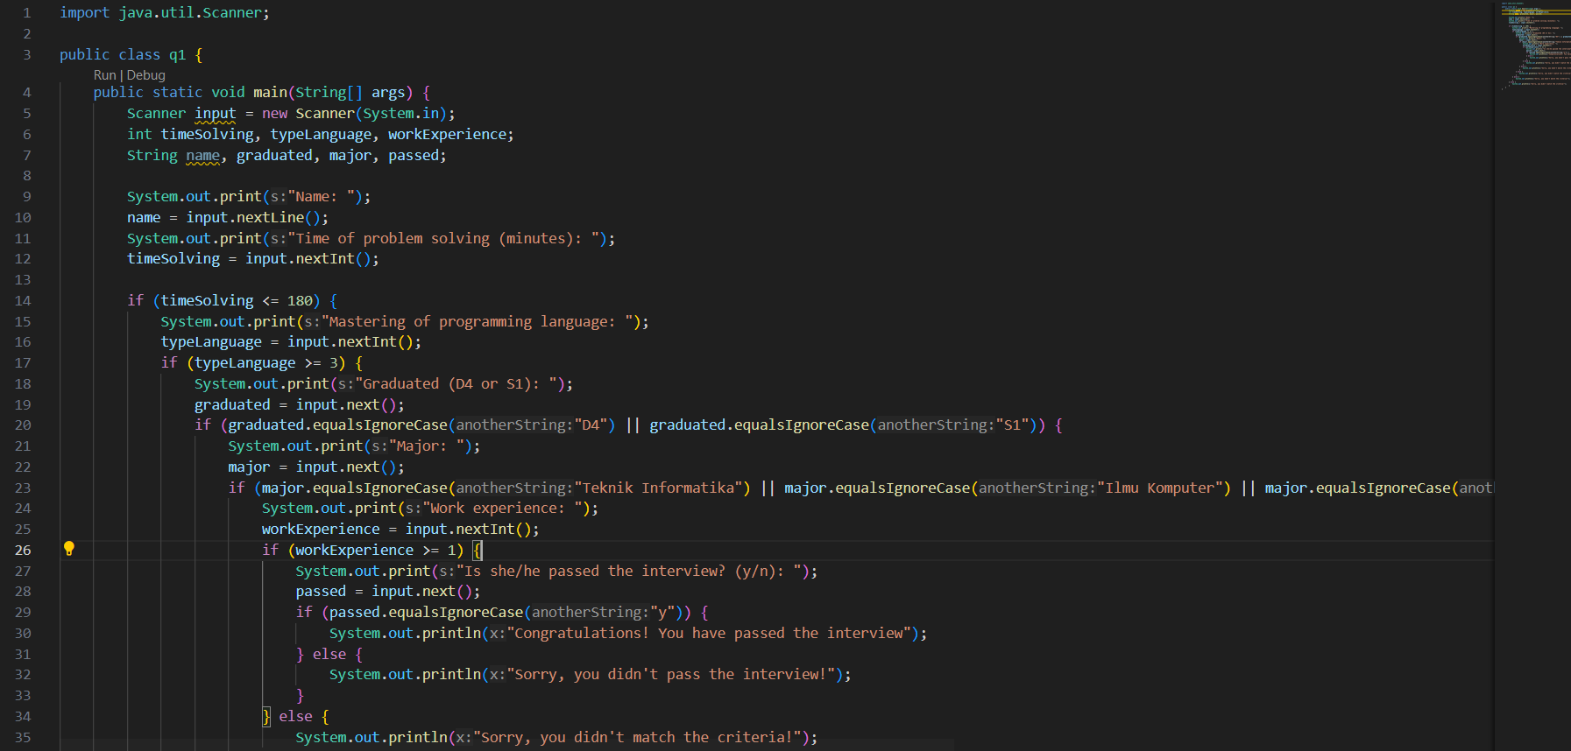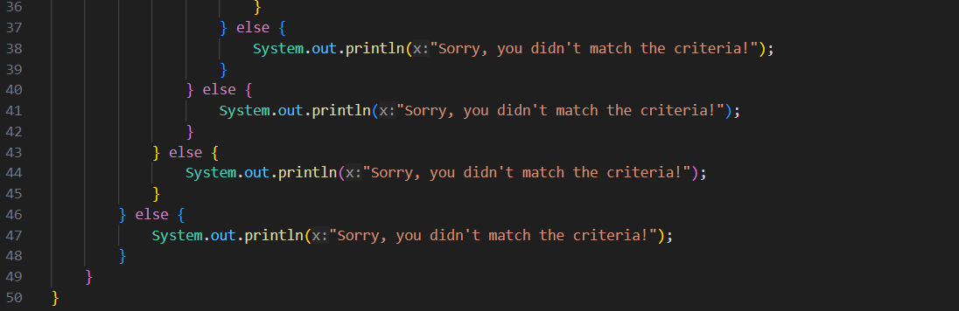

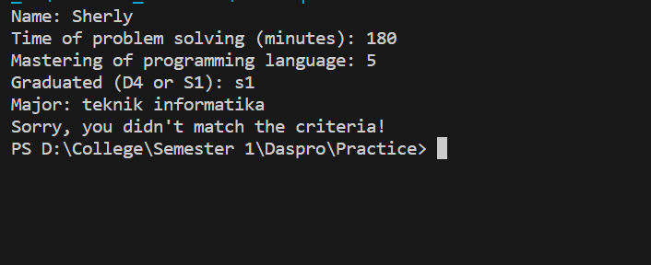

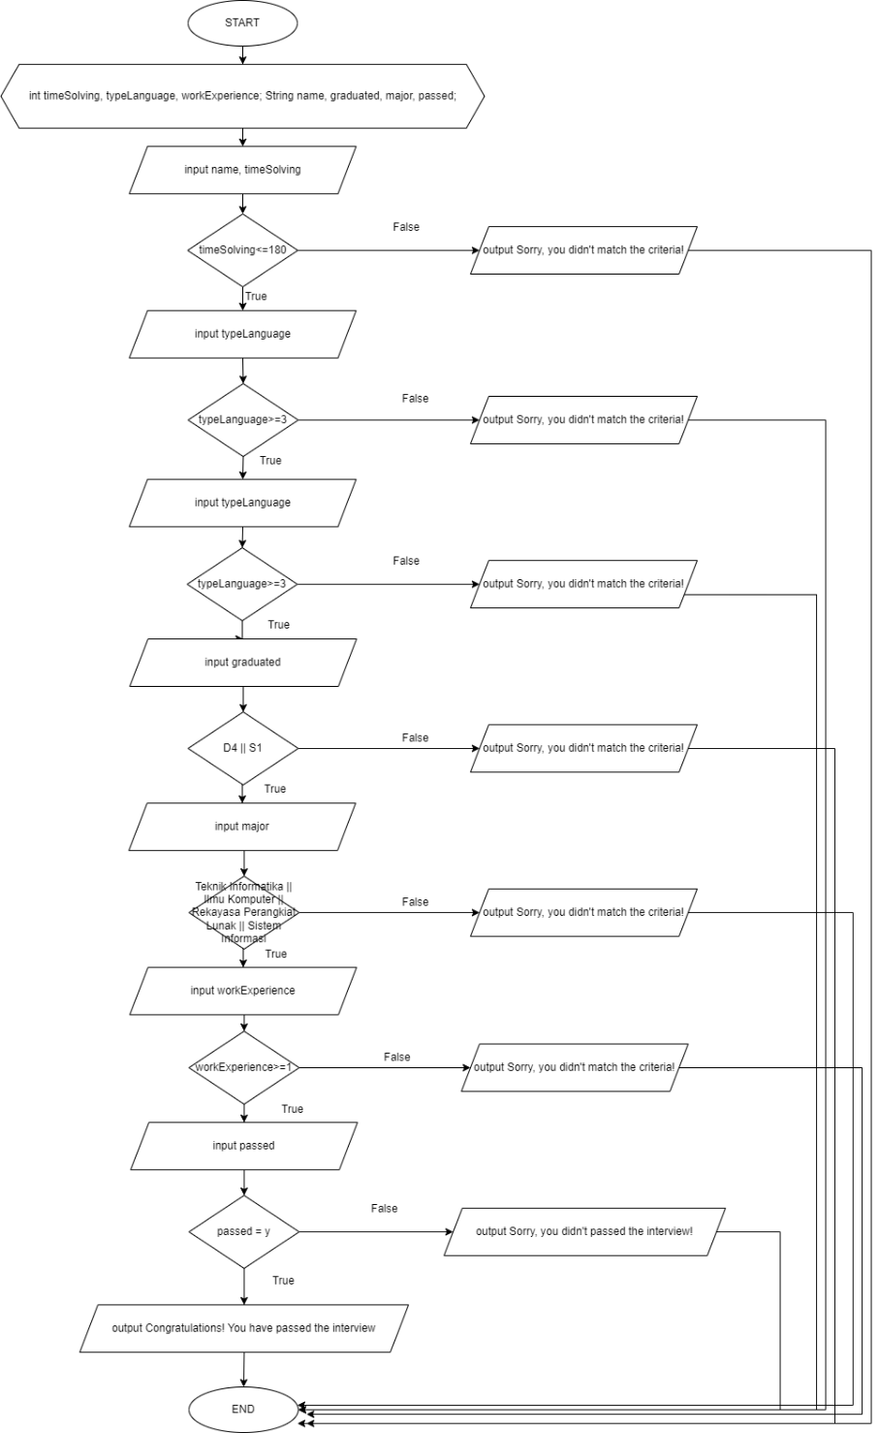

Question 2

Create a program (60%) to display and sum a series of numbers as shown below:

1.0 + 2.5 + 2.0 + 3.5 + 3.0 + 4.5 + 4.0 + ... + 99.0 = 9948.0

Also, provide an explanation of the program (40%) which can be in the form of a flowchart or narrative!

Here's a Java program that uses a for loop to display and sum the series of numbers as shown, followed by an explanation of how the program works:

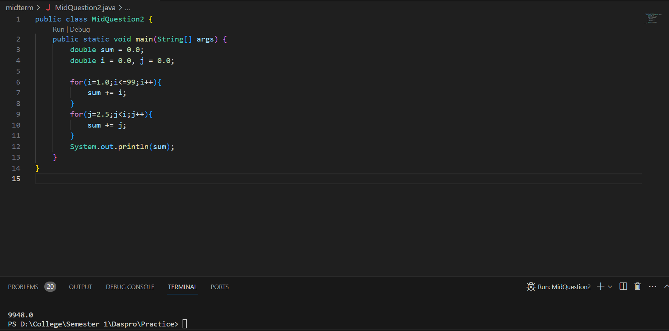

The first series is a simple increment of integers from 1 to 99, and the second series is an increment of numbers starting from 2.5 up to the value of 'i,' which is the upper limit of the first series.